

CMP 220 – Mini-Project 2

By:
Muhammed Kamran - B00064929
Amna Al Ali - G00067024
Section 2
Due: May 7, 2017

Answer:

media.h

#include <iostream>
#include <string>
#include <fstream>
using namespace std;

#pragma once

enum MediaType { magazine, book, newspaper, film, none }; //MediaType enum

class Media { //The Abstract Class Media
public:
Media(string p = "none", char status = 'A', int barCode = 1) //Default Constructor
{
title = p;

this->status = status;
this->barCode = barCode;
mt = none;

med_items++;
mediaID = med_items;
}
Media(const Media &a) //Copy Constructor
{
title = a.title;

this->status = a.status;
this->barCode = a.barCode;
mt = none;

med_items++;
mediaID = med_items;
}
Media & operator=(const Media &a) //Overloaded Operator =
{

title = a.title;

this->status = a.status;
this->barCode = a.barCode;

return *this;
}
virtual ~Media() = 0 //Destructor
{
med_items--;
}
virtual int getBarCode() = 0;// returns the bar-code of the media item
virtual void print() = 0 // virtual print
{
cout << "Media ID: " << mediaID << endl
<< "Title: " << title << endl
<< "BarCode: " << barCode << endl
<< "Status: " << status << endl;
}

virtual int getMediaID() = 0 { return mediaID; } //returns Media ID
virtual int getItems() = 0 { return med_items; } //returns Items
Media &ChangeAvailable(char letter) //Status change
{
status = letter;
return *this;
}

virtual void Output(ofstream &output) = 0 //Outputs items to stock.txt
{
output << title << "," << barCode << "," << status << ",";
}

virtual char getStatus() = 0 { return status; } //returns status
virtual MediaType getMediaType() = 0; //returns MediaType
protected:
string title;
int barCode;
char status; // ‘A’: available in stock, ‘S’: sold.
MediaType mt; // enum- 0: Magazine, 1: Book, 2: Newspaper, 3:Film.
static int med_items;
int mediaID;
};

int Media::med_items = 0;

Media-Film.h

#include "media.h"
#pragma once

class Film : public Media
{
public:
Film(string p = "none", char status = 'A', int barCode = 1, string actor = "none", int prod_year = 0)
:Media(p, status, barCode) //Default Constructor
{
this->actor = actor;
this->prod_yr = prod_year;
mt = film;
film_items++;
}
Film(const Film &a) //Copy Constructor
:Media(a)
{
this->actor = a.actor;
this->prod_yr = a.prod_yr;
mt = film;
film_items++;
}
~Film() //Destructor
{
film_items--;
}
Film &operator=(const Film &a) //Overloaded Operator =
{
Media::operator=(a);

this->actor = a.actor;
this->prod_yr = a.prod_yr;
mt = a.mt;

return *this;
}
int getBarCode(){ return barCode; } //returns barcode
virtual void print() //print function
{
cout << "Media Type: Film\n";
Media::print();
cout << "Leading Actor: " << actor << endl
<< "Production Year: " << prod_yr << endl << endl;
}
virtual void Output(ofstream &output) //Outputs items to stock.txt
{
output << "Film,";
Media::Output(output);
output << actor << "," << prod_yr << endl;
}
MediaType getMediaType() { return mt; } //return MediaType
virtual int getItems() { return film_items; } //return Media Items
virtual int getMediaID() { return mediaID; } //return Media ID
virtual char getStatus() { return status; } //return Status
private:
string actor;
int prod_yr;
static int film_items;
};
int Film::film_items = 0;

Media-Printed.h

#include "media.h"
#pragma once

class Printed : public Media
{
public:
Printed(string p = "none", char status = 'A', int barCode = 1, int no_of_pages = 0, int date_of_print = 0)
:Media(p, status, barCode) //Default Constructor
{
this->no_of_pages = no_of_pages;
this->date_of_print = date_of_print;

print_items++;
}

Printed(const Printed &a) //Copy Constructor
:Media(a)
{
this->no_of_pages = a.no_of_pages;
this->date_of_print = a.date_of_print;

print_items++;
}

~Printed() //Destructor
{
print_items--;
}

Printed & operator=(const Printed &a) //Overloaded Operator =
{
Media::operator=(a);

this->no_of_pages = a.no_of_pages;
this->date_of_print = a.date_of_print;
mt = a.mt;

return *this;
}

int getBarCode() //returns barcode
{
return barCode;
}

int get_no_of_pages() { return no_of_pages; }
int get_date_of_print() { return date_of_print; }

virtual void print() //print function
{
Media::print();
cout << "Pages: " << no_of_pages << endl
<< "Date of Print: " << date_of_print << endl;

}
virtual void Output(ofstream &output) //Outputs items to stock.txt
{
Media::Output(output);
output << no_of_pages << "," << date_of_print << ",";
}
virtual MediaType getMediaType() { return mt; }
virtual int getItems() { return print_items; }
virtual int getMediaID() { return mediaID; }
virtual char getStatus() { return status; }
protected:
int no_of_pages;
int date_of_print;
static int print_items;
};

int Printed::print_items = 0;

Printed-Book.h

#include "Media-Printed.h"
#pragma once

class Book : public Printed
{
public:
Book(string p = "none", char status = 'A', int barCode = 1, int no_of_pages = 0, int date_of_print = 0, string auth = "none", string pub = "none", int isbn = 0)
:Printed(p, status, barCode, no_of_pages, date_of_print) //Default Constructor
{
author = auth;
publisher = pub;
this->isbn = isbn;
bk_items++;
mt = book;
}

Book(const Book &a) //Copy Constructor
:Printed(a)
{
author = a.author;
publisher = a.publisher;
isbn = a.isbn;
bk_items++;
mt = book;
}

~Book() //Destructor
{
bk_items--;
}

Book & operator=(const Book &a) //Overloaded operator =
{
Printed::operator=(a);

author = a.author;
publisher = a.publisher;
isbn = a.isbn;
mt = a.mt;

return *this;
}

string getAuthor() { return author; }
string getPublisher() { return publisher; }
int getISBN() { return isbn; }
virtual int getItems(){ return bk_items; }

virtual void print() //print function
{
cout << "Media Type: Book\n";
Printed::print();
cout << "Author: " << author << endl
<< "Publisher: " << publisher << endl
<< "ISBN: " << isbn << endl << endl;
}
virtual void Output(ofstream &output) //Outputs items to stock.txt
{
output << "Book,";
Printed::Output(output);
output << author << "," << publisher << "," << isbn << endl;
}
private:
string author;
string publisher;
int isbn;
static int bk_items;
};

int Book::bk_items = 0;

Printed-Magazine.h

#include "Media-Printed.h"

#pragma once

class Magazine : public Printed
{
public:
Magazine(string p = "none", char status = 'A', int barCode = 1, int no_of_pages = 0, int date_of_print = 0, int issn = 0, string pub_name = "none", int vol = 0)
:Printed(p, status, barCode, no_of_pages, date_of_print) //Default Constructor
{
this->issn = issn;
publisher_name = pub_name;
volume = vol;

mag_items++;
this->mt = magazine;
}

Magazine(const Magazine &a) //Copy Constructor
:Printed(a)
{
issn = a.issn;
publisher_name = a.publisher_name;
volume = a.volume;

mag_items++;
this->mt = magazine;
}

~Magazine() //Destructor
{
mag_items--;
}

Magazine & operator=(const Magazine &a) //Overloaded operator =
{
Printed::operator=(a);

issn = a.issn;
publisher_name = a.publisher_name;
volume = a.volume;

this->mt = a.mt;

return *this;
}
int getISSN() { return issn; } //returns ISSN
string getPublisherName() { return publisher_name; } //return publishers name
int getVolume() { return volume; } //returns volume

virtual void print() //print function
{
cout << "Media Type: Magazine\n";
Printed::print();
cout << "ISSN: " << issn << endl
<< "Publisher Name: " << publisher_name << endl
<< "Volume: " << volume << endl << endl;
}
virtual void Output(ofstream &output) //Outputs items to stock.txt
{
output << "Magazine,";
Printed::Output(output);
output << publisher_name << "," << issn << "," << volume << endl;
}
virtual int getItems() { return mag_items; } //returns magazine items
private:
int issn;
string publisher_name;
int volume;
static int mag_items;
};

int Magazine::mag_items = 0;

Printed-Newspaper.h

#include "Media-Printed.h"
#pragma once

class Newspaper : public Printed
{
public:
Newspaper(string p = "none", char status = 'A', int barCode = 1, int no_of_pages = 0, int date_of_print = 0, string city = "none", int volume = 0)
:Printed(p, status, barCode, no_of_pages, date_of_print) //Default Constructor
{
this->city = city;
this->volume = volume;
news_items++;
mt = newspaper;
}
Newspaper(const Newspaper &a) //Copy Constructor
:Printed(a)
{
this->city = a.city;
this->volume = a.volume;
news_items++;
mt = newspaper;
}
~Newspaper() //Destructor
{
news_items--;
}
Newspaper & operator=(const Newspaper &a) //Overloaded Oprator =
{
Printed::operator=(a);
this->city = a.city;
this->volume = a.volume;
mt = a.mt;

return *this;
}
virtual void print() //print function
{
cout << "Media Type: Newspaper\n";
Printed::print();
cout << "City: " << city << endl
<< "Volume: " << volume << endl << endl;

}
virtual void Output(ofstream &output) //Outputs items to stock.txt
{
output << "Newspaper,";
Printed::Output(output);
output << city << "," << volume << endl;
}
string getCity() { return city; } //returns city name
int getVolume() { return volume; } //returns volume number
virtual int getItems() { return news_items; } //returms items

private:
string city;
int volume;
static int news_items;
};
int Newspaper::news_items = 0;

SaleTranxs.h

#include "Transaction.h"
#pragma once

class SaleTranxs
{
public:
SaleTranxs() //Default Constructor
{
ptrans = new Transaction*[0];
count = 0;
}

~SaleTranxs()
{
for (int i = 0; i < count; i++)
{
delete ptrans[i];
}

delete[] ptrans;
}

SaleTranxs &operator+= (const Transaction& a) //Overloaded Operator = to add a new transaction
{
Transaction** next = new Transaction*[count + 1];
for (int i = 0; i < count; i++)
{
next[i] = new Transaction(*ptrans[i]);
}
next[count] = new Transaction(a);

for (int i = 0; i < count; i++)
{
delete ptrans[i];
}

delete[] ptrans;

ptrans = next;
count++;

return *this;

}

void TransactionBuy(const StockTab &a) //Transaction Buy function to buy an item
{
char payment;
float amount;
int mediaID;

cout << "Items available:\n\n";
printAvailableStock(a); //prints stock

cout << "\n\nChoose method of payment (C for credit card, S for cash): ";
cin >> payment; //payment method
payment = toupper(payment);
if (payment != 'S' && payment != 'C')
return;
cout << "Enter amount to be paid: ";
cin >> amount;
cout << "Input media ID for item: ";
cin >> mediaID;

Media* ptr = NULL; //initializes media ptr as a NULL pointer to check for the user's input

for (int i = 0; i < a.getitemCount(); i++)
{
if (mediaID == a.getMPTR(i)->getMediaID())
{
ptr = a.getMPTR(i);
break;
}
}

for (int i = 0; i < count; i++)
{
if (mediaID == ptrans[i]->getMPTR()->getMediaID())
{
ptr = ptrans[i]->getMPTR();
break;
}
}

if (ptr == NULL)
{
cout << "Media Item not found...\n";
return;
}

*this += Transaction('S', payment, amount, ptr);
}

void TransactionReturn() //Transaction Return function to return an item
{
Media *ptr;
char payment;
float amount;
string title, publisher_name, author, city, actor;
int barCode, option, no_of_pages, date_of_print, issn, volume, prod_yr;

cout << "Choose method of payment (C for credit card, S for cash): ";
cin >> payment;
cout << "Enter amount to be paid: ";
cin >> amount;

cout << "Enter title of media: ";
cin.ignore();
getline(cin, title);
cout << "Enter barcode: ";
cin >> barCode;

cout << "Enter Media Type:\n"
<< "1-Magazine\n"
<< "2-Book\n"
<< "3-Newspaper\n"
<< "4-Film\n"
<< "Input: ";
cin >> option;

if (option <= 3 && option >= 1)
{
cout << "Input number of pages: ";
cin >> no_of_pages;
cout << "Input year of print: ";
cin >> date_of_print;

if (option == 1)
{
cout << "Input ISSN: ";
cin >> issn;
cout << "Input publisher name: ";
cin.ignore();
getline(cin, publisher_name);
cout << "Input volume: ";
cin >> volume;

ptr = new Magazine(title, 'A', barCode, no_of_pages, date_of_print, issn, publisher_name, volume);
}

else if (option == 2)
{
cout << "Input author: ";
cin.ignore();
getline(cin, author);
cout << "Input publisher name: ";
cin.ignore();
getline(cin, publisher_name);
cout << "Input ISBN: ";
cin >> issn;

ptr = new Book(title, 'A', barCode, no_of_pages, date_of_print, author, publisher_name, issn);
}

else if (option == 3)
{
cout << "Input city: ";
cin.ignore();
getline(cin, city);
cout << "Input volume: ";
cin >> volume;

ptr = new Newspaper(title, 'A', barCode, no_of_pages, date_of_print, city, volume);
}
}

else if (option == 4)
{
cout << "Input leading actor: ";
cin.ignore();
getline(cin, actor);
cout << "Input production year: ";
cin >> prod_yr;

ptr = new Film(title, 'A', barCode, actor, prod_yr);
}

*this += Transaction('R', payment, amount, ptr);
}

void TransactionReplace(const StockTab &a) //Transaction Replace function to replace an item
{
TransactionBuy(a);
TransactionReturn();
}

void print() const //prints Transaction report
{
if (count == 0)
return;

cout << "TRANSACTION REPORT:\n\n";

for (int i = 0; i < count; i++)
{
ptrans[i]->print();
}
}

void printSoldStock() const //prints sold stocks
{
if (count == 0)
return;

cout << "SOLD STOCK REPORT:\n\n";
for (int i = 0; i < count; i++)
if (ptrans[i]->getMPTR()->getStatus() == 'S')
ptrans[i]->getMPTR()->print();
}

void printAvailableStock(const StockTab &a) const //prints available stock
{
if (count == 0 && a.getAvailableCount() == 0)
return;

a.printAvailableStock();
for (int i = 0; i < count; i++)
if (ptrans[i]->getMPTR()->getStatus() == 'A')
ptrans[i]->getMPTR()->print();
}

int getAvailableCount(const StockTab &a) //returns available items
{
int x = a.getAvailableCount();
for (int i = 0; i < count; i++)
if (ptrans[i]->getMPTR()->getStatus() == 'A')
x++;

return x;
}

int getCount() const { return count; } //returns itme count

void Output(ofstream &output, const StockTab &a) //Outputs items to stock.txt
{
output << getAvailableCount(a) << endl;
for (int i = 0; i < a.getitemCount(); i++)
if (a.getMPTR(i)->getStatus() == 'A')
a.getMPTR(i)->Output(output);

for (int i = 0; i < count; i++)
{
if (ptrans[i]->getMPTR()->getStatus() == 'A')
ptrans[i]->getMPTR()->Output(output);
}
}
private:
Transaction **ptrans;
int count;
};

StockTab.h

#include "Media-Film.h"
#include "Printed-Book.h"
#include "Printed-Magazine.h"
#include "Printed-Newspaper.h"
#include <fstream>

#pragma once

class StockTab
{
public:
StockTab(int itemCount = 0) //Default Constructor
{
this->itemCount = itemCount;

mptr = new Media*[this->itemCount];
}

~StockTab() //Destructor
{
for (int i = 0; i < itemCount; i++)
delete mptr[i];

delete[] mptr;
}

StockTab & Add(ifstream &input, MediaType mt, int index) //takes mt from input and adds stock.txt files to mptr
{
string titleMedia, publisher_nameMagazine, authorBook, publisherBook, cityNewspaper, actorFilm;
int barCodeMedia, no_of_pagesPrinted, date_of_printPrinted, issnMagazine, volumeMagazine, isbnBook, volumeNewspaper, prod_yrFilm;
char statusMedia, dummy;
switch (mt)
{
case magazine:
getline(input, titleMedia, ',');
input >> barCodeMedia >> dummy >> statusMedia >> dummy;
input >> no_of_pagesPrinted >> dummy >> date_of_printPrinted >> dummy;
getline(input, publisher_nameMagazine, ',');
input >> issnMagazine >> dummy >> volumeMagazine;

mptr[index] = new Magazine(titleMedia, statusMedia, barCodeMedia, no_of_pagesPrinted, date_of_printPrinted, issnMagazine, publisher_nameMagazine, volumeMagazine);
break;
case book:
getline(input, titleMedia, ',');
input >> barCodeMedia >> dummy >> statusMedia >> dummy;
input >> no_of_pagesPrinted >> dummy >> date_of_printPrinted >> dummy;
getline(input, authorBook, ',');
getline(input, publisherBook, ',');
input >> isbnBook;

mptr[index] = new Book(titleMedia, statusMedia, barCodeMedia, no_of_pagesPrinted, date_of_printPrinted, authorBook, publisherBook, isbnBook);
break;
case newspaper:
getline(input, titleMedia, ',');
input >> barCodeMedia >> dummy >> statusMedia >> dummy;
input >> no_of_pagesPrinted >> dummy >> date_of_printPrinted >> dummy;
getline(input, cityNewspaper, ',');
input >> volumeNewspaper;

mptr[index] = new Newspaper(titleMedia, statusMedia, barCodeMedia, no_of_pagesPrinted, date_of_printPrinted, cityNewspaper, volumeNewspaper);
break;
case film:
getline(input, titleMedia, ',');
input >> barCodeMedia >> dummy >> statusMedia >> dummy;
getline(input, actorFilm, ',');
input >> prod_yrFilm;

mptr[index] = new Film(titleMedia, statusMedia, barCodeMedia, actorFilm, prod_yrFilm);
break;
default:
break;
}
return *this;
}

void input(ifstream &input) //inputs the mediatype from stock.txt
{
string MedType;

for (int i = 0; i < itemCount; i++)
{
input.ignore();
getline(input, MedType, ',');

if (MedType == "Magazine")
Add(input, magazine, i);

else if (MedType == "Book")
Add(input, book, i);

else if (MedType == "Newspaper")
Add(input, newspaper, i);

else if (MedType == "Film")
Add(input, film, i);

else
{
cout << "Invalid media type...\n";
exit(1);
}
}
}

void print() const //prints stock
{
for (int i = 0; i < itemCount; i++)
{
mptr[i]->print();
}
}

void printSoldStock() const //prints sold stock
{
cout << "SOLD STOCK REPORT:\n\n";

for (int i = 0; i < itemCount; i++)
if (mptr[i]->getStatus() == 'S')
mptr[i]->print();
}

void printAvailableStock() const //prints available stock
{

for (int i = 0; i < itemCount; i++)
if (mptr[i]->getStatus() == 'A')
mptr[i]->print();
}

int getAvailableCount() const //returns item amount
{
int x = 0;
for (int i = 0; i < itemCount; i++)
if (mptr[i]->getStatus() == 'A')
x++;

return x;
}

int getitemCount() const{ return itemCount; } //returns count
Media *getMPTR(int i) const { return mptr[i]; } //returns mptr
private:
int itemCount;
Media **mptr;
};

Transaction.h

#include "media.h"
#pragma once

class Transaction
{
public:
Transaction(char type = 'S', char payment = 'S', float amount = 0, Media *mptr = NULL) //Default Constructor
{
this->type = type;
this->payment = payment;
this->amount = amount;
this->mptr = mptr;

switch (type)
{
case 'S':
this->mptr->ChangeAvailable('S');
break;
case 'R':
this->mptr->ChangeAvailable('A');
break;
default:
break;
}

count++;
trans_id = count;
}

void print() const //prints transaction
{
cout << "Transaction ID: " << trans_id << endl
<< "Type: " << type << endl
<< "Payment: ";
switch (payment)
{
case 'S':
cout << "Cash\n";
break;
case 'C':
cout << "Credit Card\n";
break;
default:
cout << "Invalid Transaction\n";
break;
}
cout << "Amount: " << amount << endl;

mptr->print();
}

Media* getMPTR() { return mptr; } //return mpts
private:
int trans_id;
char type; // ‘S’: sale, ‘R’: return. ‘P’: replace..etc.
char payment; // method of payment. ‘C’: credit card. ‘S’: cash
float amount; //
Media * mptr;
static int count;// pointer to the media item involved in the transaction
};
int Transaction::count = 0;

stock.txt before execution

5
Magazine,HAHAHA,893249,A,233,2009,publshirt,23984023,23
Magazine,HAHAHA,893249,A,133,2019,publshirt,844023,24
Film,HEHEHEHE,234234,A,John Doe,1998
Book,HOHOHO,234234,A,233,1997,JAY JAY,publpants,849
Book,FOJOF,22332,A,323,1120,joewijf,efwjfw efw,2424

driver.cpp

#include "StockTab.h"
#include "SaleTranxs.h"
using namespace std;

void main()
{
ifstream input("stock.txt");

int n;
input >> n;

string str_dummy;
StockTab stock(n);
stock.input(input);
SaleTranxs table;

int option;
while (1)
{
cout << "Please select form the following menu : " << endl;
cout << endl;
cout << "1.Buy a media item " << endl;
cout << "2.Return a media item" << endl;
cout << "3.Replace a media item " << endl;
cout << "4.Generate Available Stock Report " << endl;
cout << "5.Generate Sold Stock Report " << endl;
cout << "6. Generate Transaction Report" << endl;
cout << "7.Close" << endl << endl;

cout << "Please enter your choice : ";
cin >> option;

input.close();
ofstream output("stock.txt");
switch (option)
{
case 1:
table.TransactionBuy(stock); //calls the TransactionBuy function
break;
case 2:
table.TransactionReturn(); //calls the TransactionReturn function
break;
case 3:
table.TransactionReplace(stock); //calls the TransactionReplace function
break;
case 4:
cout << “AVAILABLE STOCK REPORT\n\n”;
table.printAvailableStock(stock); //displays the available stock report
break;
case 5:
table.printSoldStock(); //prints the sold items from StockTab
break;
case 6:
table.print(); //prints all items currently in SaleTranxs table
break;
case 7:
//closes the file
table.Output(output, stock);
exit(1);
output.close();
break;
default:
cout << "Invalid option...\n";
break;
}
}
}

Output:

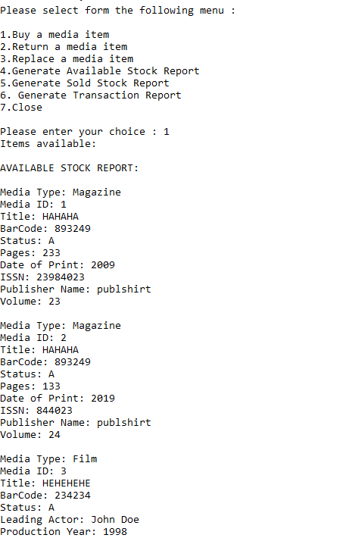

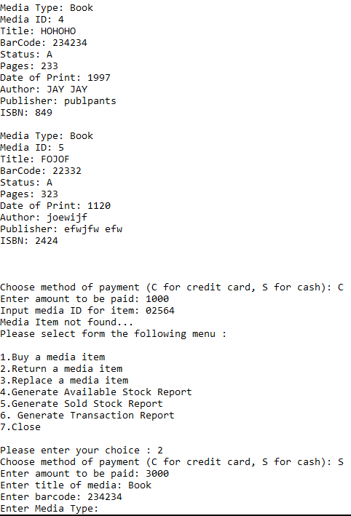

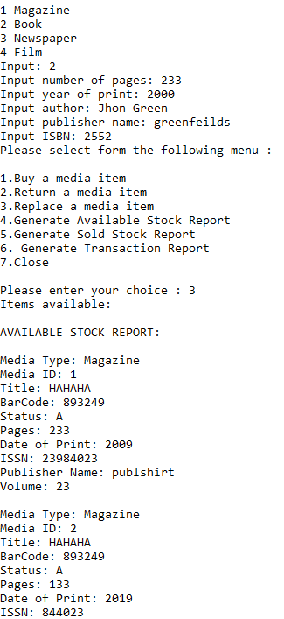

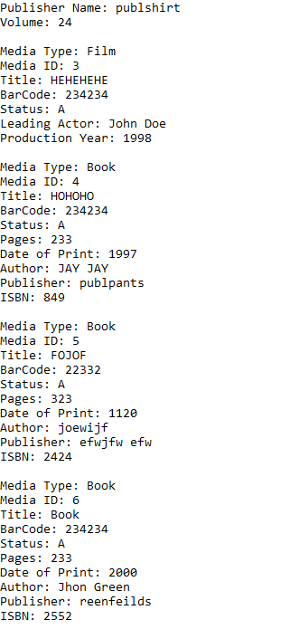

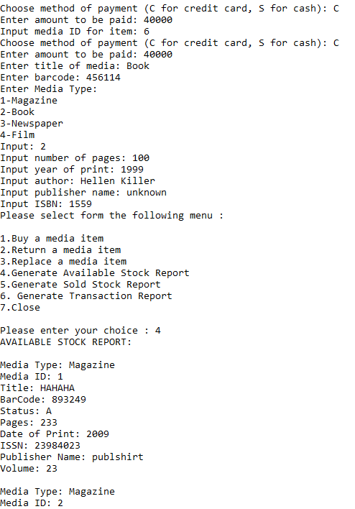

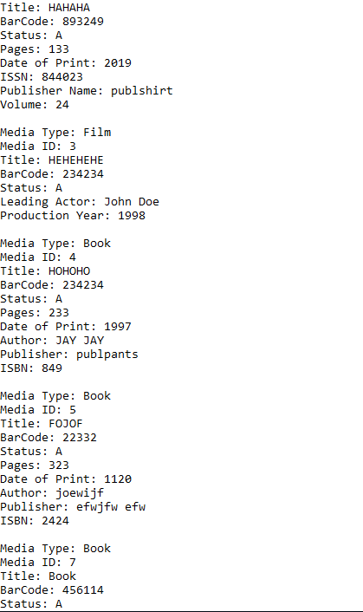

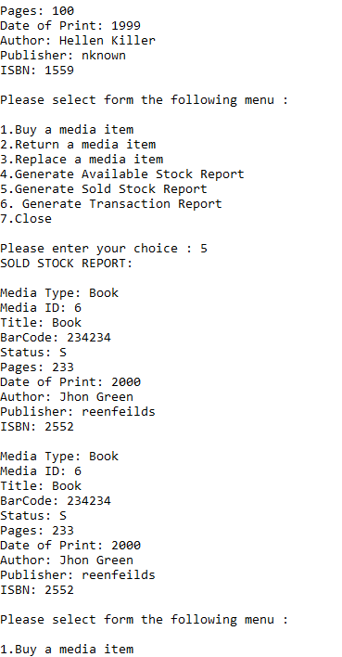

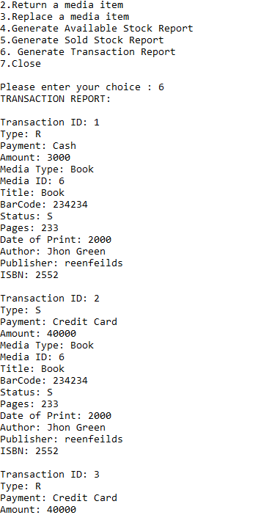

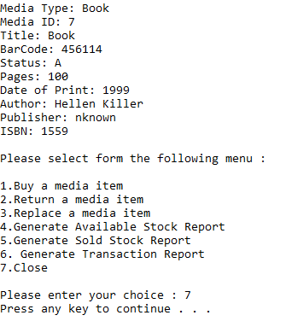

stock.txt after execution
